Project Design Document

1. Design Intent
- What experience are you trying to create?
The aim is to recreate the excitement and interaction of a classic arcade claw machine. The experience is designed to feel engaging and rewarding, with responsive controls, visual feedback, and sound cues that make gameplay immersive and enjoyable.

- Who is it for?
The machine is designed for a wide age group (10–50+ years), including students, young adults, and older users. It is simple and intuitive enough for first-time users, while still offering a fun challenge that appeals across age groups.

- If solving a problem, what problem does it solve?
The project explores how physical interaction and simple mechanics can create engaging user experiences. It addresses the challenge of translating a familiar arcade interaction into a functional, small-scale prototype while balancing usability, feedback, and mechanical limitations.

2. Inspiration & References
- Inspiration
https://www.instructables.com/Arduino-Claw-Machine/
https://www.hackster.io/theSTEMpedia/candy-claw-machine-arduino-based-arcade-game-f51ee6
https://www.youtube.com/watch?v=XqT0NzsYdEA

- What did you learn from them?
  - From the Instructables project, we understood how a claw machine can be designed as a complete system with gantry movement, servo-based gripping, and a timer-based game loop. It also showed how real arcade machines rely more on timing and control rather than just randomness.
  - From the Hackster project, we learned about the integration of multiple components like joystick control, motors, sensors, and feedback systems. It helped us understand how XY movement, vertical motion, and claw control can work together in a structured way.
  - From the YouTube reference, we got a clearer idea of the user experience and physical interaction, especially how lights, sound, and rewards (like candy) make the system more engaging and game-like.

3. User Journey
Step-by-step experience of the user:
- User approaches the machine and inserts a coin
- System responds with arcade sound and LED animation → game begins
- User grabs the joystick and starts moving the claw, exploring the space
- User looks for a target while the timer runs in the background
- User positions the claw and presses the button
- System takes over → claw opens, moves down, grabs, and lifts up
- Claw automatically moves to the drop zone
- Claw releases the object
- System checks result → brief moment of anticipation
- System responds:
- Green lights + sound → user wins
- Red lights + sound → user loses
- User reacts and collects reward (if won)
- System resets and waits for the next user

4. Success Criteria
- Functional
Claw responds to joystick input within < 0.5–1 second
Servo completes open/close action within ≤ 1.5 seconds
LED and sound feedback trigger within < 0.5 seconds of coin insertion or result
Ultrasonic sensor detects object accurately within ≤ 10 cm range with ≥ 90% accuracy

- User experience
Users able to understand joystick controls within < 1 minute
Successful object pickup achieved in at least 3 out of 5 attempts
Movement remains smooth with minimal jitter during continuous use (≥ 1 minute)

- Reliability
System runs without failure for at least 5 consecutive trials
No major lag or crash during 1-minute gameplay cycle
Sensor and motor performance remains consistent with ≤ 10% variation across trials

5. System Overview
- High-level explanation of system
The system is a coin-operated claw machine controlled by an ESP32, where the game begins when a coin is detected using an IR sensor. Once triggered, the system activates a timed gameplay sequence, allowing the user to control the claw’s movement using a joystick. On pressing a button, an automated sequence controls the claw to move down, grab an object using a servo, and return to its original position. The claw then moves to a fixed drop location, where an ultrasonic sensor checks if the object has been successfully collected. Based on this, the system provides visual (LED) and audio (buzzer) feedback for win or loss, and resets itself for the next user.

- What are the main parts?
  - Input System: IR sensor, joystick, push button, ultrasonic sensor
  - Processing Unit: ESP32 running MicroPython to handle logic, timing, and sequencing
  - Mechanical System: DC motors (gantry movement), servo motor (claw), thread and pulley mechanism
  - Output System: NeoPixel LEDs (visual feedback), buzzer (audio feedback)

6. High-Level Block Diagram
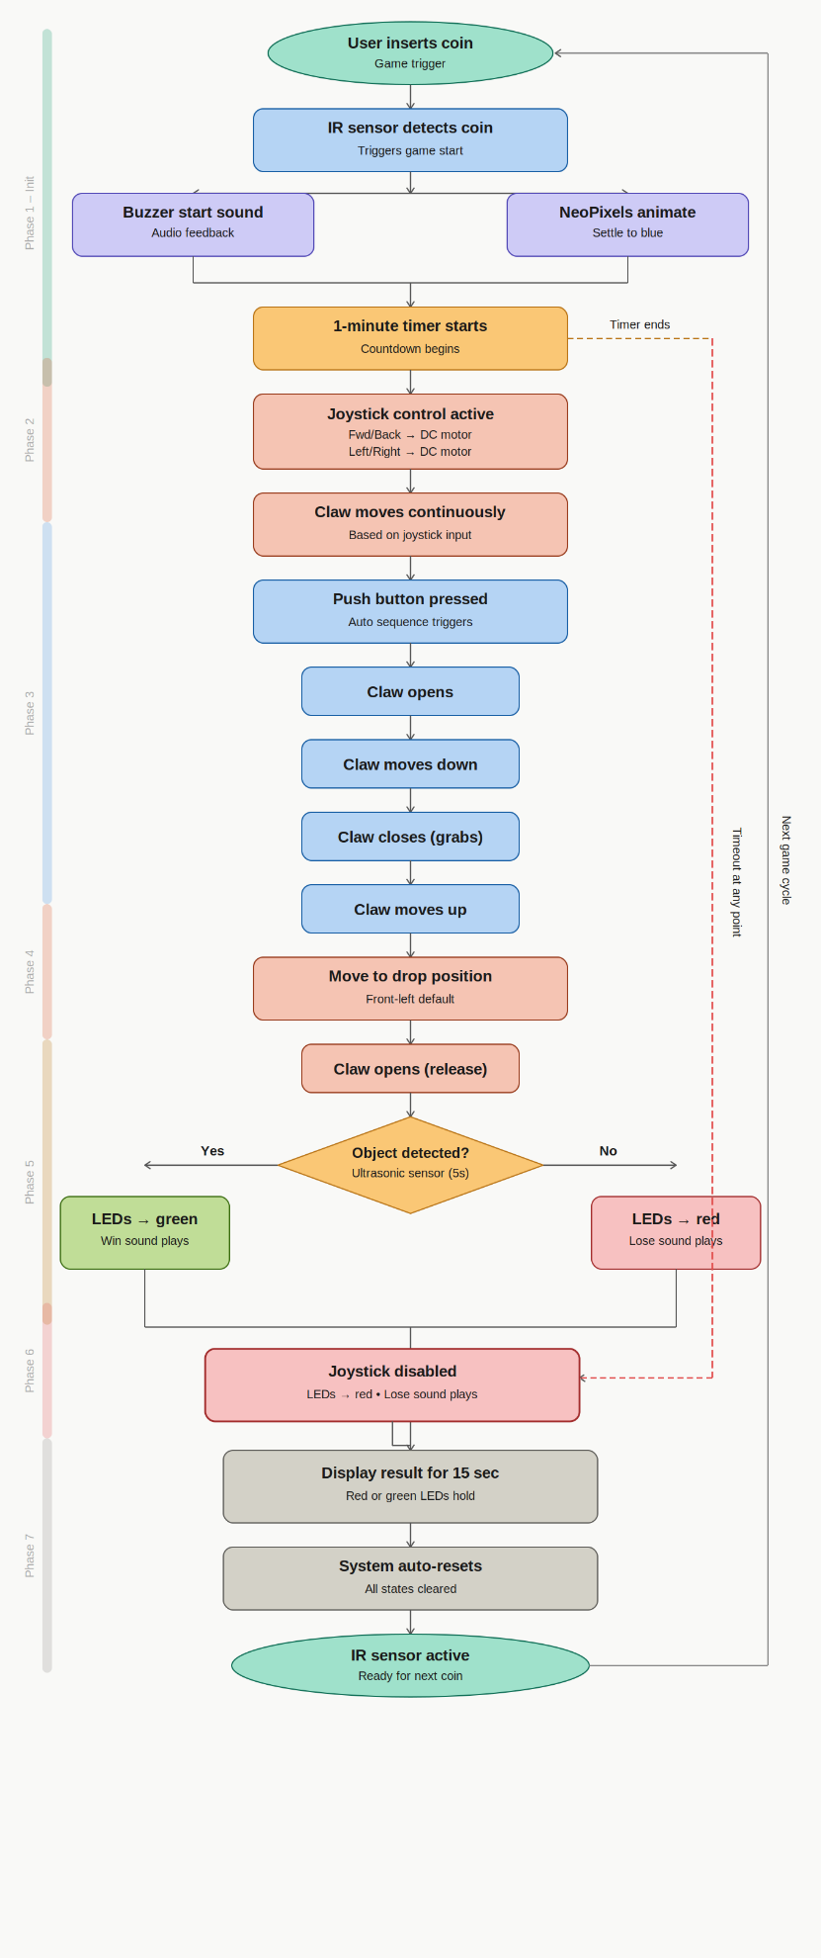

7. Input / Output Mapping
Input | Process | Output
IR Sensor | Detects coin insertion and triggers game start sequence | Buzzer plays start sound, NeoPixel LEDs animate and turn blue, timer starts
Joystick | Reads directional input (analog values) and maps it to motor movement | DC motors move claw forward/backward and left/right
Push Button | Triggers automated claw sequence | Claw opens → moves down → closes → moves up (DC motor + Servo motor)
Ultrasonic Sensor | Measures distance to detect presence of object in collection area | Determines win/lose → LEDs turn green/red, buzzer plays corresponding sound
Timer (1 minute) | Tracks gameplay duration | Triggers losing condition (red LEDs + buzzer)

8. Sketches & Concepts
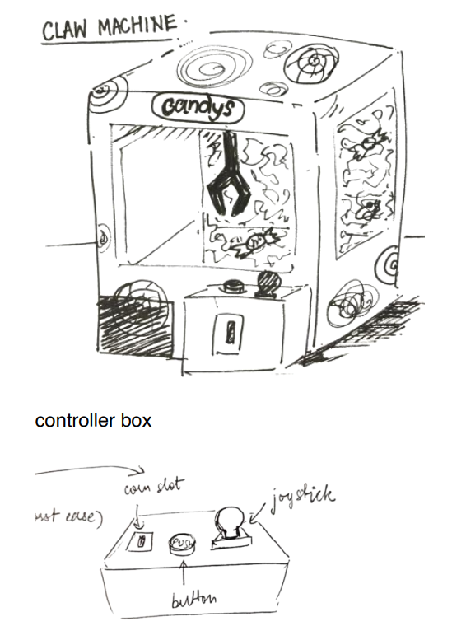

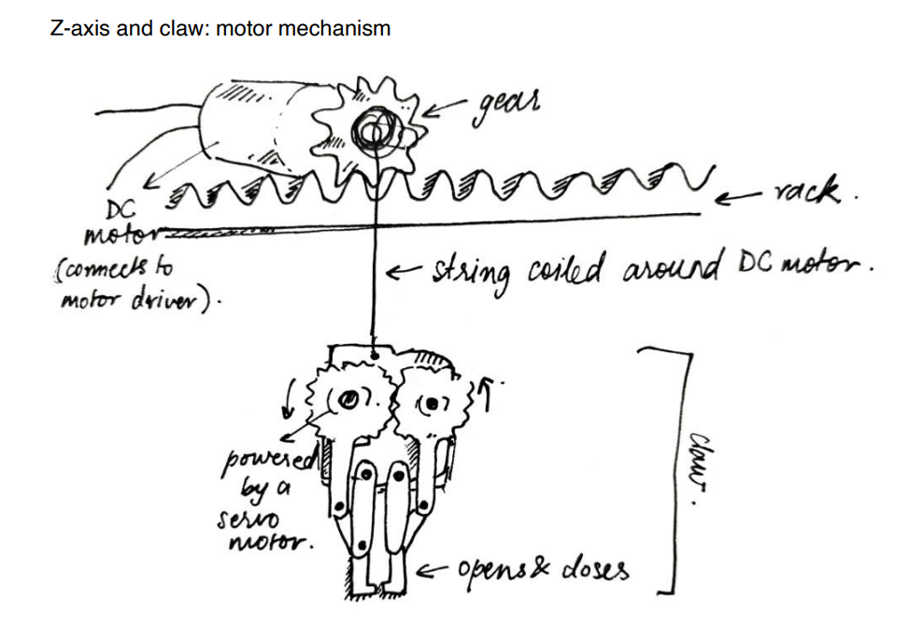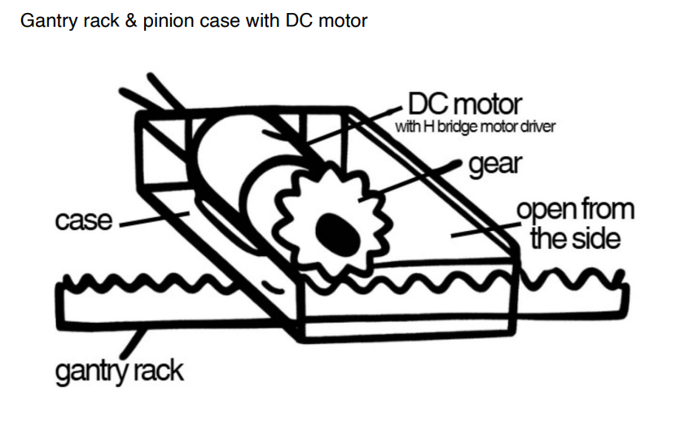

9. Final System Architecture (Labelled)
